1/27/2015

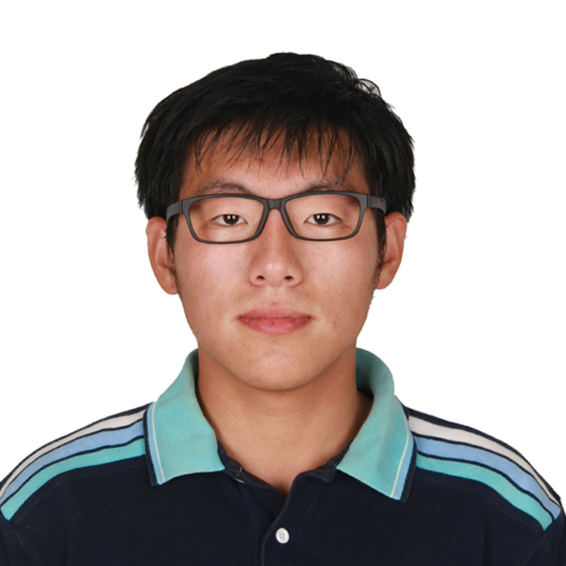

HW1 ELEC345

# Part 1

## Exercise 1

## 

• Crop the head of the tiger from the image.



• Save the cropped sub-image as a PNG file.



• Display the red component of the cropped image.



• Change the order of the color components to [Green,Red,Blue] for the original image and display the image. {Don’t use loops}



## Exercise 2

## 

• Convert the image to gray scale.



• Blur the gray scale image by using a Gaussian filter of size 5×5 with standard deviation 2.



• Subtract the blurred image from the original gray scale image.



• Threshold the resultant image at 5% of its maximum pixel value.



• Display the final image.

PS: It is hard to see the difference. So I enhanced (intensity * 10) to compare image without and with threshold



# Part 2

## Filtering

I1 filtering result:

|  |  |  |  |  |
| --- | --- | --- | --- | --- |
|  | 125 | 120 | 93 |  |
|  | 133 | 107 | 75 |  |
|  | 95 | 65 | 35 |  |
|  | 53 | 33 | 23 |  |
|  | 28 | 18 | 10 |  |

|  |  |  |  |  |
| --- | --- | --- | --- | --- |
|  |  |  |  |  |
| 130 | 123 | 100 | 68 | 35 |
| 115 | 93 | 73 | 38 | 22 |
| 80 | 60 | 37 | 20 | 12 |
|  |  |  |  |  |

|  |  |  |  |  |
| --- | --- | --- | --- | --- |
|  |  |  |  |  |
|  | 118 | 97 | 68 |  |
|  | 94 | 68 | 44 |  |
|  | 59 | 39 | 23 |  |
|  |  |  |  |  |

I2 filtering result:

|  |  |  |  |  |
| --- | --- | --- | --- | --- |
|  | 125 | 120 | 118 |  |
|  | 133 | 120 | 117 |  |
|  | 60 | 55 | 43 |  |
|  | 35 | 30 | 13 |  |
|  | 15 | 12 | 5 |  |

|  |  |  |  |  |
| --- | --- | --- | --- | --- |
|  |  |  |  |  |
| 110 | 107 | 102 | 87 | 95 |
| 80 | 73 | 75 | 57 | 57 |
| 38 | 33 | 38 | 25 | 18 |
|  |  |  |  |  |

|  |  |  |  |  |
| --- | --- | --- | --- | --- |
|  |  |  |  |  |
|  | 106 | 98 | 94 |  |
|  | 76 | 68 | 63 |  |
|  | 36 | 32 | 27 |  |
|  |  |  |  |  |

This part I did the first one by hand, the second one I used filtering function in the matlab.

• Apply following filters on the gray scale image of Barbara from Part I.

1. Central difference Gradient filter



2. Sobel filter



3. Mean filter



4. Median filter



## Smoothing

1. Box (averaging) filters of sizes 2×2,4×4,8×8,16×16.



2. Gaussian filter of standard deviations 2, 4, 8, 16 (A good choice of gaussian filter size is 4 times its standard deviation, in order to include most of the variability within the box).



I think 8*8 average box works best here, with significant noise reduction with most details reserved.

When the box is bigger, the image get smoothed out even more to the scale of the box size.

Similar thing happens when you change the standard deviation for gauss filter. You lost high frequency detail up to the standard deviation.